Arteriolosclerosis Annotation Protocol
Create subfolder in each ID_XXX: ID_XXX_Masks, ID_XXX_Negative, ID_XXX_Positive ( create ID_XXX_Maybe, ID_XXX_Repeats, and ID_XXX_CannotAnnotate if needed)
Subfolder definition
- Masks: put the annotated masks here (instructions in the next section)
- Negative: not arteriolosclerosis
- Positive: arteriolosclerosis and able to annotate
- Maybe: not sure whether it’s positive/negative
- Repeats: put repeated tiles here without determining if they’re positive/negative
- CannotAnnotate: possible arteriolosclerosis but not able to annotate because of too small magnification or incomplete view of the vessel 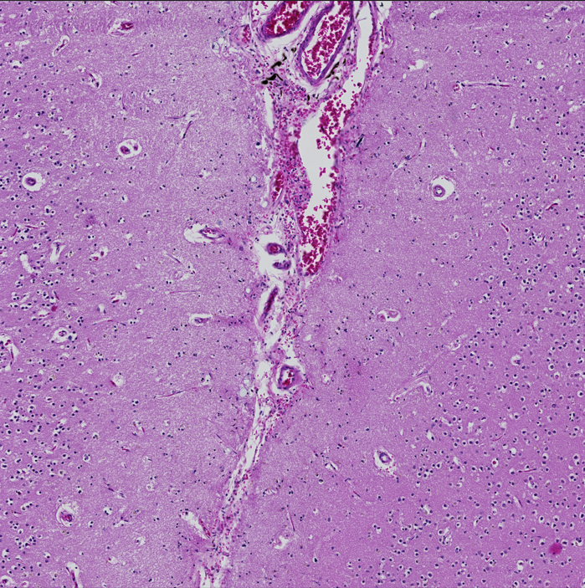
Positive arteriolosclerosis
- Cross-section rather than longitudinal
- Need to see the lumen clearly (or it’s hard to train the computer model)
- Need to be in white matter only, not in gray matter or leptomeninges
 | Thickening of the media | Decreased lumen size | Loss of smooth muscle cells
None
Mild | ✔
Moderate | ✔ | ✔ | ✔
Severe | ✔ | ✔ | ✔ (complete loss)

Reference:
Vascular cognitive impairment neuropathology guidelines (VCING): the contribution of cerebrovascular pathology to cognitive impairment (Skrobot et al, 2016)
graphs from Brain Arteriolosclerosis (Blevins et al, 2021)
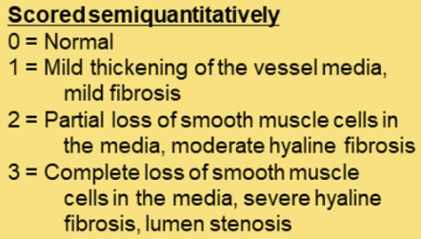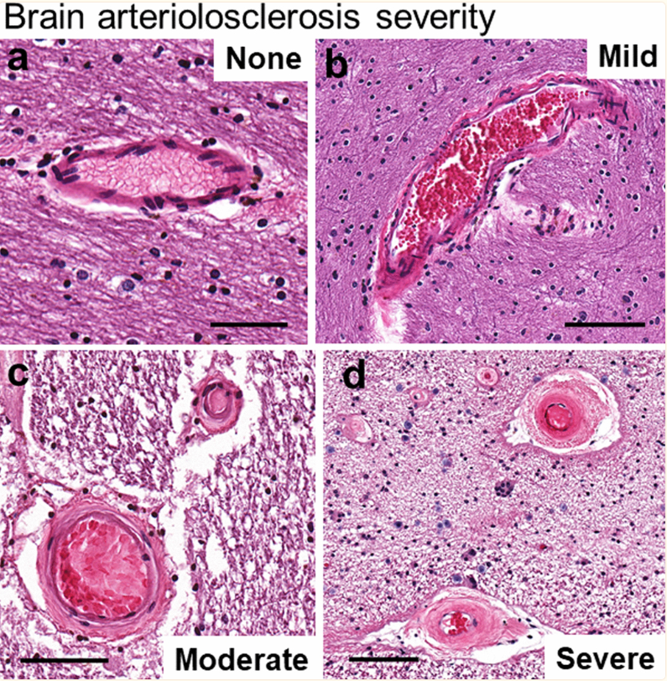

How to annotate
- Open Image J (Fiji) 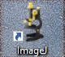
- Copy the file name of the positive tile > drag the file to Image J window (or import via File > Open)
- Double click the oval shape brush > check “Enable selection brush” > normally set 50 pixels for vessel border and 25 pixels for lumen border (can adjust based on different tiles)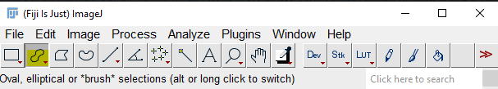 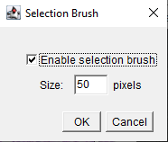
- Draw the vessel border by holding left click 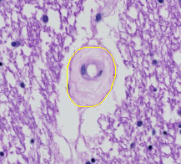
  - If 2 positive vessels: shift and hold left click to draw
  - To erase: draw from outside to trim the border
- Click Edit > Selection > Create Mask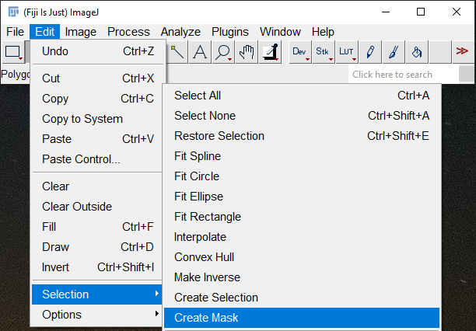
- You should get the vessel area as white and the background as black as below. If not, click Edit > Invert (or Ctrl+Shift+I) 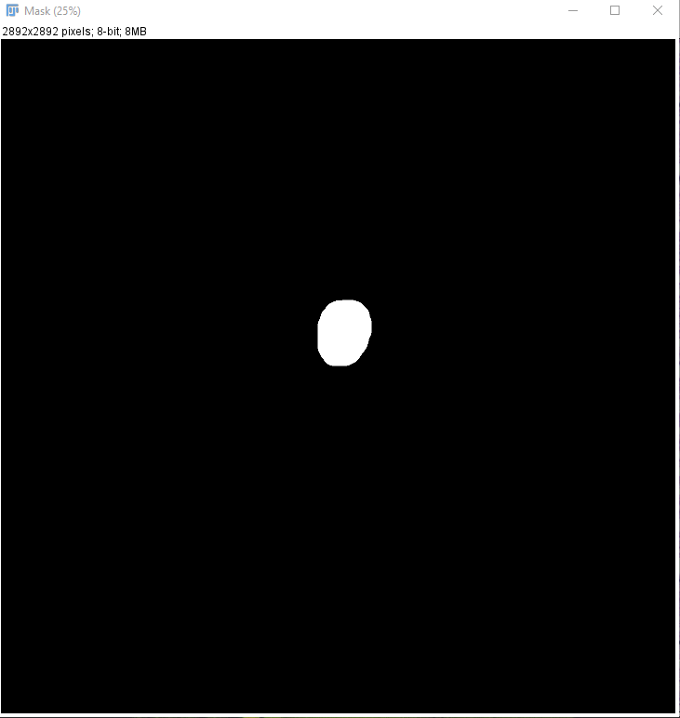
- Save the mask by clicking File > Save As > PNG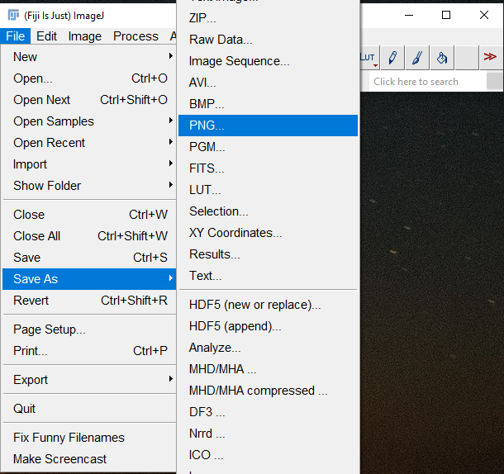
- Paste the file name that you copied in Step 2 in front of the Mask.png (make sure to save the masks in the subfolder ID_XXX_Masks) 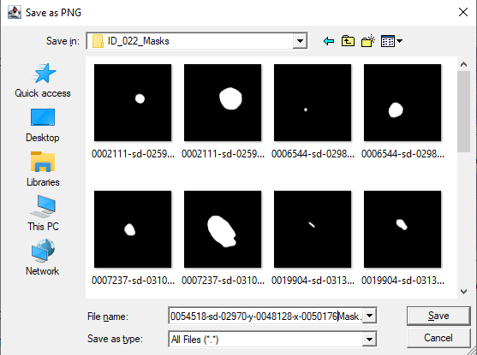
- Close the mask window and go back to annotate the lumen border 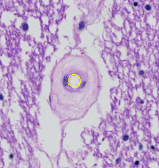
- Create a mask the same as Step 5-7
- Paste the file name that you copied in Step 2 and put L before Mask.png to indicate the lumen mask 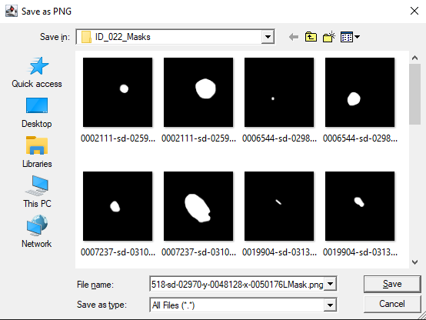
- Repeat the steps above for the next tile

